 | 26.3 Editors - Properties Editor - Output Properties Tab
Table of content
Detailed table of content 1
Output Properties Tab 4
Render Engine 5
Dimensions Panel 5
Presets 5
Resolution X / Y 5
Aspect X / Y 5
Render Region 6
Frame Rate 6
Frame Range Panel 6
Frame Start / End 6
Frame Step 6
Time Stretching 6
Stereoscopy Panel 7
Workflow 7
Stereo 3D / Multiview 8
List of Cameras 9
Add / Remove / Rename 9
Suffix 9
Output Views Subpanel 9
Output Panel 12
File Path 12
Load File 12
File Format 12
Transparent 15
Options subpanel 15
Color management subpanel 16
Transparent subpanel 19
Metadata Panel 19
Metadata Input 20
Include 20
Note 20
Burn into Image 20
Post Processing Panel 21
Pipeline 21
Dither 21

Detailed table of content

Detailed table of content
Detailed table of content 1
Output Properties Tab 4
Dimensions Panel 5
Presets 5
Resolution X / Y 5
Aspect X / Y 5
Render Region 5
Crop to Render Region 6
Frame Start / End 6
Frame Step 6
Frame Rate 6
FPS 6
Base 6
Time Remapping 6
Old 6
New 6
Stereoscopy Panel 6
Workflow 7
Stereo 3D / Multiview 8
List of Cameras 8
Resize handler 8
Search field 8
Add / Remove / Rename 9
Suffix 9
Output Views Subpanel 9
Individual 9
Stereo 3D 9
Stereo Mode 9
Stereo Mode Type Anaglyph 9
Anaglyph Type 10
Stereo Mode Type Interlace 10
Interlace Type 10
Swap Left/Right 10
Stereo Mode Type Side by Side 10
Cross Eyed 10
Squeezed Frame 10
Stereo Mode Type Top Bottom 11
Squeezed Frame 11
Output Panel 11
File Path 11
Load File 11
File Format 12
Image file formats 12
BMP 12
Color 12
Iris 12
Color 12
PNG 12
Color 12
Color Depth 12
Compression 12
JPEG 12
Color 12
Quality 12
JPEG 2000 12
Color 12
Color Depth 12
Quality 12
Codec 13
Cinema 13
Cinema (48) 13
YCC 13
Targa 13
Color 13
Targa Raw 13
Cineon 13
Color 13
DPX 13
Color 13
Color Depth 13
Log 13
Open EXR Multilayer 13
Color 13
Color Depth 13
Codec 13
Preview 14
Open EXR 14
Color 14
Color Depth 14
Codec 14
Z Buffer 14
Preview 14
Radiance HDR 14
Color 14
TIFF 14
Color 14
Color Depth 14
Compression 14
Movie file formats 14
AVI Jpeg 14
Color 14
Quality 14
AVI Raw 15
Color 15
FFmpeg video 15
Color 15
Transparent 15
Options subpanel 15
Saving 15
File Extensions 15
Cache Result 15
Image Sequence 15
Overwrite 15
Placeholders 15
Color management subpanel 15
Color management settings 15
Follow scene 15
Override 16
Display Device 16
View Transform 16
Standard 16
Filmic 16
Filmic Log 16
Raw 16
False Color 16
Look 16
Exposure 16
Gamma 17
Use Curves 17
Navigation elements 17
Zoom in and out 17
Tools 17
Reset View 17
Vector Handle 17
Auto Handle 17
Auto Clamped Handle 17
Extend Horizontal 17
Extend Extrapolated 17
Reset Curve 17
Use Clipping 17
Delete Points 18
Black Level 18
White Level 18
Hotkeys for Black and White Level 18
Reset 18
Transparent subpanel 19
Transparent Glass 19
Roughness Threshold 19
Metadata Panel 19
Metadata Input 19
Include 19
Note 19
Burn into Image 19
Font Size 20
Text Color 20
Background 20
Include Labels 20
Post Processing Panel 20
Pipeline 20
Compositing 20
Sequencer 20
Dither 20

Output Properties Tab
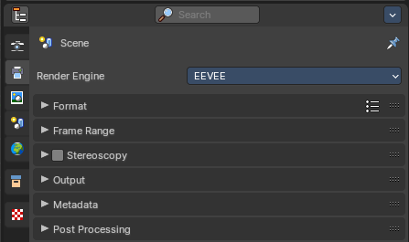
The Output properties contains all the settings to render the final image or movie. Most o fthe settings are the same for all three available render engines.

Render Engine
Shows the active render engine. Specific renderer does have other settings. And you can also switch to another renderer. But note that this is more a visual guide. It misses the Cycles render settings.

Dimensions Panel

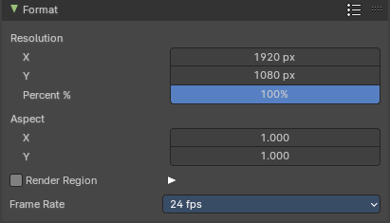
This panel contains the dimension settings.

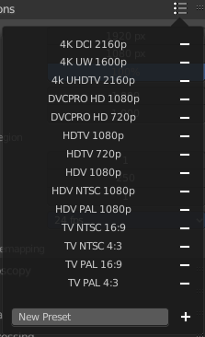
Presets
A list of dimension presets with the most common settings.
To add a new preset type in a new preset name into the edit box at the end of the list, and click at the + sign.
To remove a preset click at the - sign behind the name.
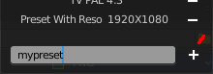

Resolution X / Y
The dimensions of the image in pixels.
%
Render the image in per cent of the original image. You can for example render in 200% of the resolution values. Or in 50%.

Aspect X / Y
The image aspect ratio. For anamorphic or non square pixel output.

Render Region
Activate render region for the output image.
There is a render region feature in the 3D view and in the Image editor where you can render a portion of the screen for preview purposes. Normally the output will always render the full image then, regardless of the render region. When you activate Render Region then the output will also render the render region only, and not the full image.

Crop to Render Region
Crop the output image to the size of the render region.

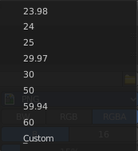
Frame Rate
The output frame rate. When you choose custom then two more properties appears.

Frame Range Panel

Frame Start / End
The start and end frame for an animation.

Frame Step
Number of frames to skip forward while playing the animation. With a value of 2 every second frame gets skipped.

FPS
The custom frame per seconds value.

Base
Frame rate base. A multiplier that makes it for example possible to set up 29,97 Frames instead of 30 for NTSC.

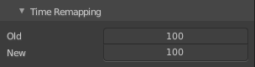
Time Stretching
Remap the length of an animation.

Old
The old length.

New
The new length.

Stereoscopy Panel

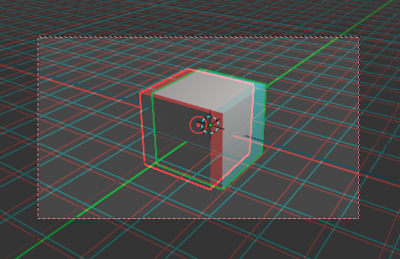
Allows you to render out stereoscopic images from the active camera. For the anaglyph images you need special stereoscopy glasses to see the 3D effect. And in case of the interlace method a 3d ready monitor and shutter glasses.

The anaglyph method is to create stereo images. The interlace method is mostly used in movies.

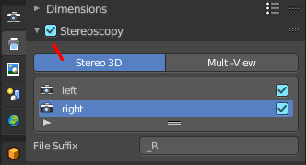
Workflow
Turn on Stereoscopy.

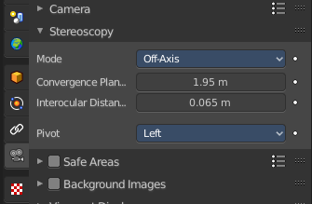
Select the Camera in the Outliner. In the Properties Editor choose the Object Data Properties tab (which should show a camera icon at this point), and open the Stereoscopy panel.
Change the Convergence Plane Distance to your needs. This can also be done in the 3D view with the handlers when you are in Camera view.
Interocular distance is the distance between the left and the right camera.
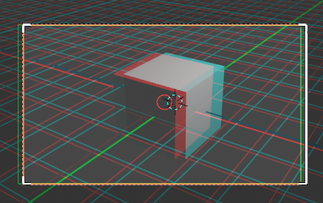

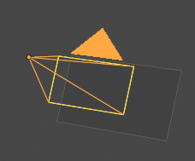
Outside of the camera view you will see this plane in front of the camera.
Adjust the plane to your needs. The plane is the reference point. Everything behind appears behind the focus. Everything before the plane appears before the focus.

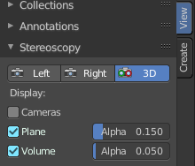
In the sidebar in the 3D view you will find further settings.
Turn on volume to see if the objects are inside of the volume.

Do a preview rendering, and adjust the settings if required.
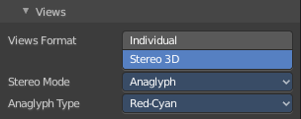
Go back to the Output tab to the Output panel. By activating stereoscopy here is a new section called Views. Here you can find further export settings.

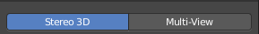
Stereo 3D / Multiview
The stereoscopy method. Stereo 3D uses two predefined virtual cameras. The camera settings gets inherited from the main camera.
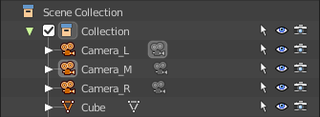
Multiview allows you to set up several cameras manually. You need to create every camera by hand. And you need to follow name conventions to get this to work. In the outliner give the cameras the suffix that you want to use in the list. Here three cameras with a suffix.

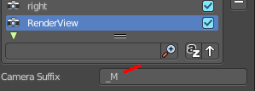
Now do the same in the list of cameras. Give every camera the same suffix than in the outliner. The camera name is not important. Important is the suffix. This is the identifier.

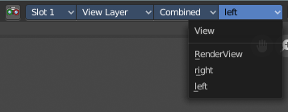
And in the render window you have now the render result of your three cameras.
Note that for stereoscopy just two cameras gets used for rendering the anaglyph or interlaced result. Usually the ones with suffix _L and _R. So our third camera does not influence the stereoscopic image here.

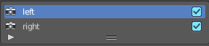
List of Cameras
The list of cameras. Note that with method Stereo 3D these cameras does not exist in the outliner. They are virtually created as child objects to the main camera that you use for rendering.
In this list you can choose the cameras to change the suffix.
The checkbox allows you to disable the cameras. Both options are just of interest for the multi-view setup. Normal stereoscopy setup does not require any further setup.

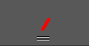
Resize handler
The resize handler allows you to resize the list.

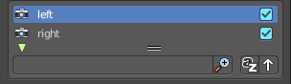
Search field
The triangle button down left allows you to open a search field.

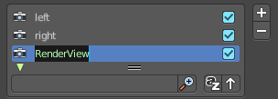
Add / Remove / Rename
Add adds a custom camera. Remove removes a custom camera. And custom cameras can be renamed by clicking at the name.
The camera names left and right can‘ t be renamed, and you can‘ t remove them from the list. Individual cameras can be renamed and removed.

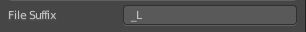
Suffix
The camera identifier. The suffix gets appended at the end of the single images of the camera. The left camera has the suffix _L, and the right camera has the suffix _R

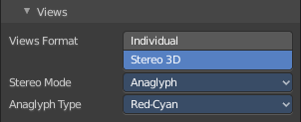
Output Views Subpanel
This subpanel just shows with Stereoscopy enabled!
Adjust the stereoscopy export settings. Note that this settings does not adjust what you view in the image editor. This settings influences what you save from the image editor then.

Individual
Save out single images from each camera when you save the result from the image editor. So for a stereoscopic image two images for the two cameras.

Stereo 3D
Save out the stereoscopic image as a single image when you save the result from the image editor.

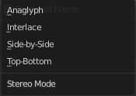
Stereo Mode
How to export the stereoscopic image with save as in the image editor. There are four methods available.

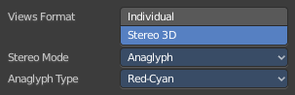
Stereo Mode Type Anaglyph
Render Views for left and right eyes as two differently filtered colors in a single image. You need anaglyph glasses to see the 3d effect.
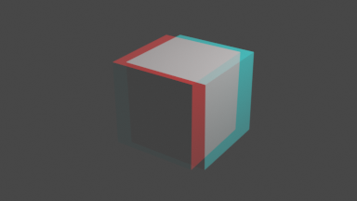

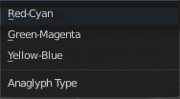
Anaglyph Type
The color model to display the graphics.

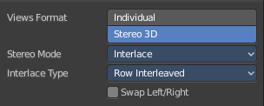
Stereo Mode Type Interlace
Render Views from left and right eyes interlaced into a single image. You need a 3D Ready monitor to see the stereo effect.
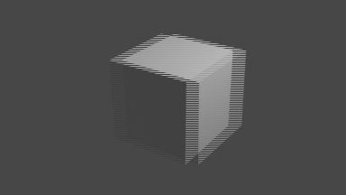

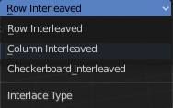
Interlace Type
The interlace type that you can choose.

Swap Left/Right
Swaps left and right camera view.

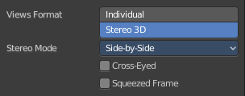
Stereo Mode Type Side by Side
Renders images of the two cameras side by side.

Cross Eyed
Swaps left and right camera view.

Squeezed Frame
Combine both views in a squeezed image.

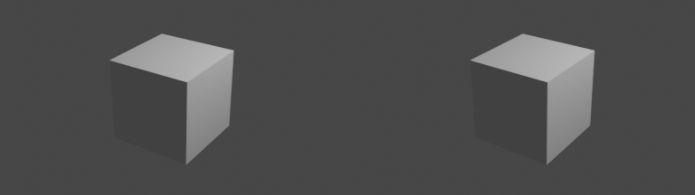

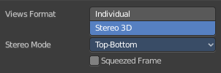
Stereo Mode Type Top Bottom
Renders images of the two cameras side by side.

Squeezed Frame
Combine both views in a squeezed image.

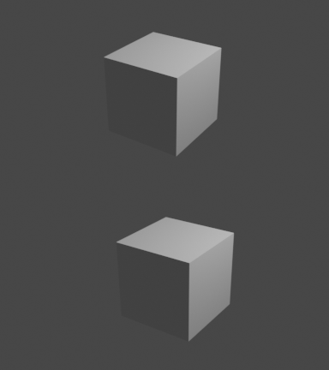

Output Panel

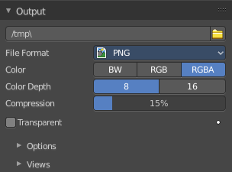
The file output settings.

File Path
The location to save rendered frames. Here you will find rendered animation sequences. For single images you can save out the result in the image editor.
When rendering an animation, the frame number is appended at the end of the file name with four padded zeros (e.g. image0001.png). You can set a custom padding size by adding the appropriate number of # anywhere in the file name (e.g. image_##_test.png translates to image_01_test.png).
This setting expands relative paths where a // prefix represents the directory of the current blend-file.

Load File
Here you can load an existing file to overwrite it. Or you can use it to load a file in a directory and rename it then to your destination file name.

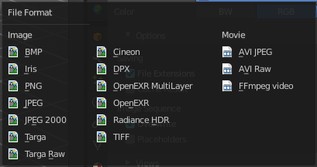
File Format
The output file format.
Each file format has some own settings.

Image file formats

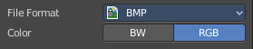
BMP

Color
The output color format. Black and white or rgb.

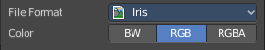
Iris

Color
The output color format. Black and white, rgb or rgba.

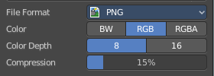
PNG

Color
The output color format. Black and white, rgb or rgba.

Color Depth
8 or 16 colors per channel.

Compression
The compression level.

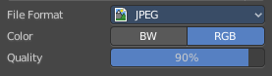
JPEG

Color
The output color format. Black and white, or rgb.

Quality
The jpeg quality.

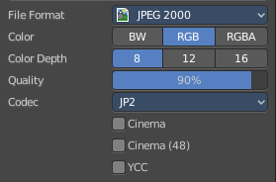
JPEG 2000

Color
The output color format. Black and white, rgb or rgba.

Color Depth
8, 12 or 16 colors per channel.

Quality
The jpeg quality.

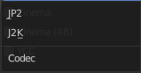
Codec
Which jpeg 2000 codec to use.

Cinema
Use OpenJpeg Cinema preset.

Cinema (48)
Use OpenJpeg Cinema (48) preset.

YCC
Save luminance / chrominance / chrominance channels instead of rgb channels.

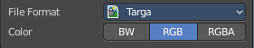
Targa

Color
The output color format. Black and white, rgb or rgba.

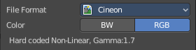
Targa Raw

Cineon

Color
The output color format. Black and white, or rgb.
Gamma of 1.7 and Non-Linear is hard coded.

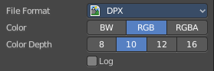
DPX

Color
The output color format. Black and white, rgb, or RGBA.

Color Depth
8, 10, 12 or 16 colors per channel.

Log
Convert to logarithmic color space.

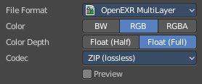
Open EXR Multilayer

Color
The output color format. Black and white, rgb, or RGBA.

Color Depth
Float half values or Float full values per channel.

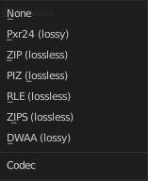
Codec
What codec to use.

Preview
When rendering animations, save Jpeg preview images into the same directory.

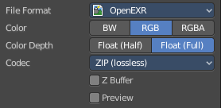
Open EXR

Color
The output color format. Black and white, rgb, or RGBA.

Color Depth
Float half values or Float full values per channel.

Codec
What codec to use.

Z Buffer
Save the Z Depth per pixel. 32 Bit unsigned int Z Buffer.

Preview
When rendering animations, save Jpeg preview images into the same directory.

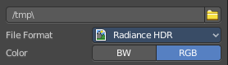
Radiance HDR

Color
The output color format. Black and white, or rgb.

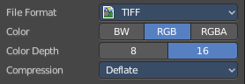
TIFF

Color
The output color format. Black and white, rgb, or RGBA.

Color Depth
8 or 16 bit per channel.

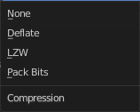
Compression
The compression method.

Movie file formats

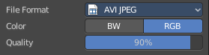
AVI Jpeg

Color
The output color format. Black and white, or rgb.

Quality
The jpeg quality.

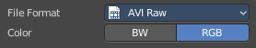
AVI Raw

Color
The output color format. Black and white, or rgb.

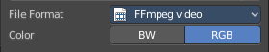
FFmpeg video

Color
The output color format. Black and white, or rgb.


Transparent
Eevee and Workbench renderer. Render and export the result with transparent background.

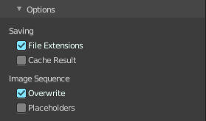
Options subpanel
Not all options are available for all file formats.

Saving

File Extensions
Adds the correct file extensions per file type to the output files.

Cache Result
Saves the rendered image and passes to a Multilayer EXR-file in temporary location on your hard drive. This allows the compositor to read these to improve performance, especially for heavy compositing.

Image Sequence

Overwrite
Overwrite existing files when rendering.

Placeholders
Create empty placeholder frames while rendering.

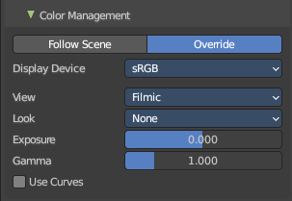
Color management subpanel

Color management settings

Follow scene
Uses the color management from the scene.

Override
Uses the color management settings that is defined below instead of the color management from the scene.
This settings is in most parts equal to the color management settings in the render properties. But has no settings for the Sequencer.

Display Device
The device that the image is being viewed on. Your monitor.
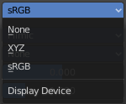
Most computer monitors are configured for the sRGB color space.
Color management can also be disabled by setting the device to None.

View Transform
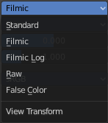
Choose between different ways to view the image on the same monitor.

Standard
Does no extra conversion besides the conversion for the display device.

Filmic
For more photo realistic results and better handling of high dynamic range. The contrast can be adjusted by changing the Look option for the Filmic view transform.

Filmic Log
Converts to Filmic log color space. This can be used for export to color grading applications, or to inspect the image by flattening out very dark and light areas.

Raw
Intended for inspecting the image but not for final export. Raw gives the image without any color space conversion.

False Color
Shows a heat map of image intensities, to visualize the dynamic range.

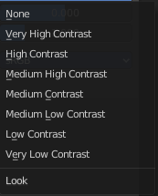
Look
Adjust the contrast.

Exposure
Used to control the image brightness (in stops) applied before color space conversion. The calculation is: output_value=render_value×2(exposure)

Gamma
Extra gamma correction applied after color space conversion. Note that the default sRGB or Rec709 color space conversions already include a gamma correction of approximately 2.2 (except the Raw and Log views), so this would be applied in addition to that.

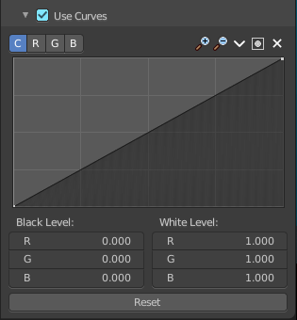
Use Curves
Adjust RGB Curves to control image colors before color space conversion.

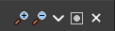
Navigation elements
The navigation elements at the top are described from left to right.

Zoom in and out
The two buttons with the magnifying glass at it zooms in and out in the curve window.

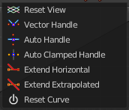
Tools
Tools is a menu that contains some cuve related tools.

Reset View
Resets the curve windows zoom.

Vector Handle
Set handle type to Vector.

Auto Handle
Set handle type to Auto.

Auto Clamped Handle
Set handle type to Auto Clamped.

Extend Horizontal
Causes the curve to stay horizontal before the first point and after the last point.

Extend Extrapolated
Causes the curve to extrapolate before the first point and after the last point, based on the shape of the curve.

Reset Curve
Resets the curve to the initial shape.


Use Clipping
Clipping options. Set up clipping for the stroke.

Delete Points
Deletes selected curve points.

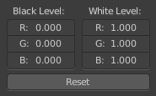
Black Level
The color that Black is mapped to.

White Level
The color that White is mapped to.

Hotkeys for Black and White Level
You may want to sample the black and white level colors directly in the image by clicking at an area. There are hotkeys for that.
Ctrl + Left Mouse click in the image sets the Black level value from that position.
Shift + Left Mouse click in the image sets the White Level value from that position.
To see the result you need to tick the View as Render button.
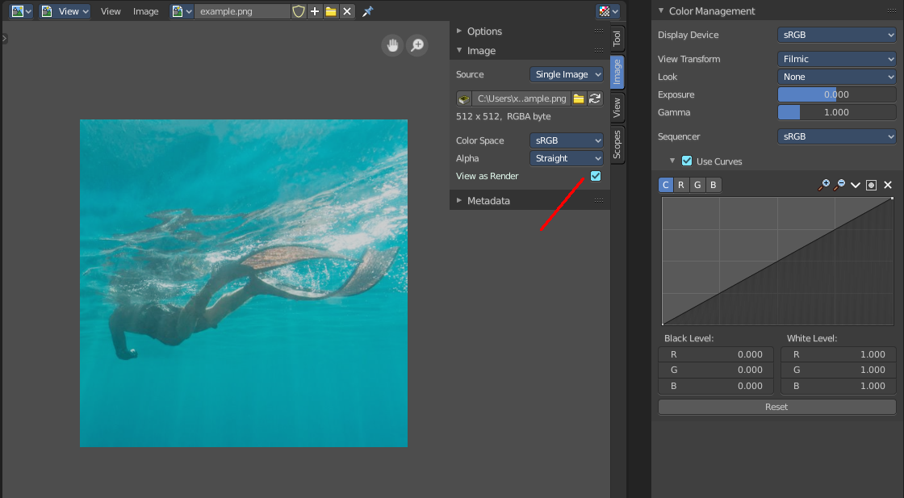

Reset
Resets the Curve and the Black and White Level values to the default values.

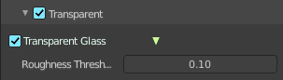
Transparent subpanel
Cycles only. Enable the rendering of transparent background.

Transparent Glass
Render glass with transparent background.

Roughness Threshold
For transparent transmission. Keep surfaces with roughness above the threshold opaque.

Metadata Panel
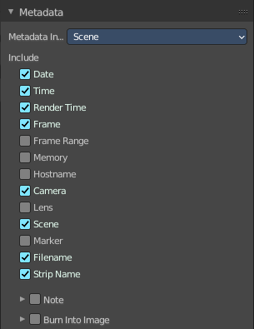
What metadata to include into the image or movie.

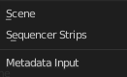
Metadata Input
Where to get the Metadata from.

Include
What Metadata to include.

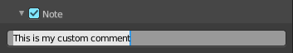
Note
Include a custom comment.

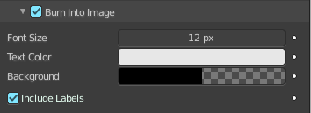
Burn into Image
Render the stamp info text into the image. The information is cluttered across the rendered image. Parts of it appears up left in the rendering. Parts down left, and parts down right.
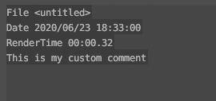
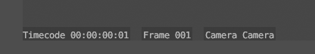
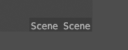

The props have decorators. This means this information can be keyframed. The font itself is the system font, and cannot be changed.

Font Size
The font size.

Text Color
The text color.

Background
The background color of the text.

Include Labels
Display stamp labels like "Camera" in front of camera name, etc.

Post Processing Panel

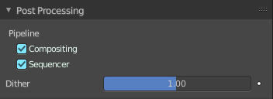
Enable Post Processing.

Pipeline

Compositing
Process the pipeline through the compositing in case compositing nodes are enabled.

Sequencer
Process the pipeline (and composited result) through the video sequence pipeline in case Sequencer strips exists.

Dither
Amount of dithering noise added to the rendered image to break up banding.
This prop has a decorator, and can be keyframe animated.

